**LAB TASK – 06**

Q#1Take a sample list [2, 1, 3, 5, 4, 3, 8]

Apply del(), remove(), sort(), insert(), pop(), extend()…)

**CODE:**

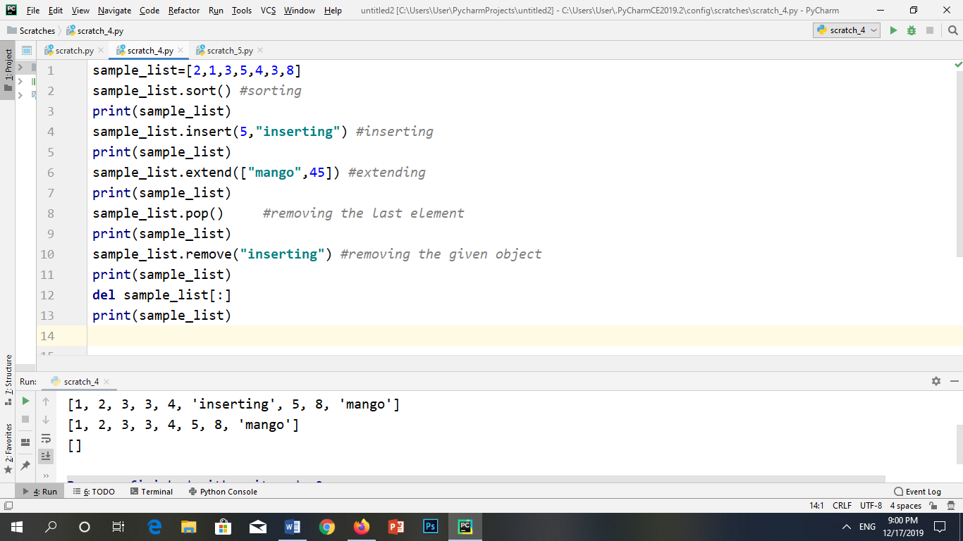

**OUTPUT:**

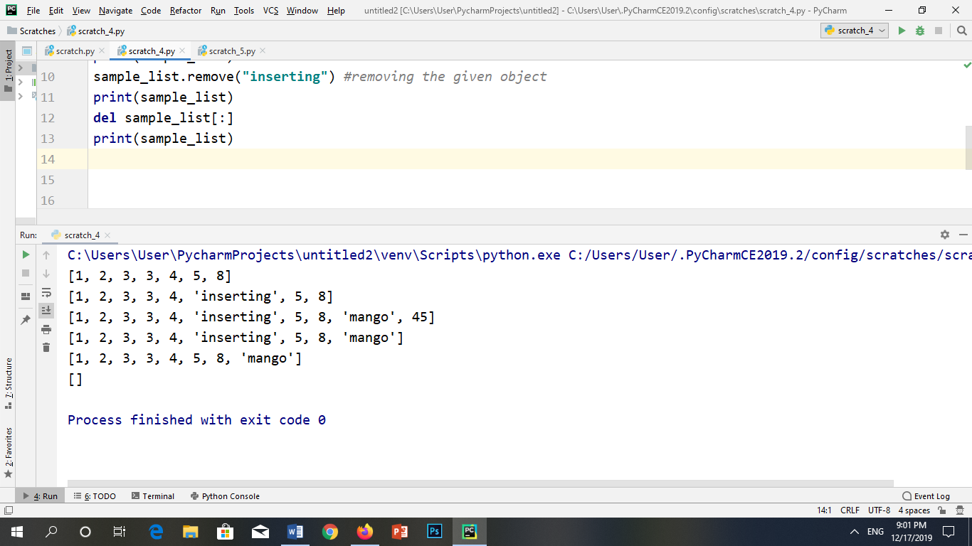

*2*. A ladder put up right against a wall will fall over unless put up at a certain angle less than 90 degrees. Given variables length and angle storing the length of the ladder and the angle that it forms with the ground as it leans against the wall, write a Python expression involving length and angle that computes the height reached by the ladder. Evaluate the expression for these values of length and angle

**(a)16 feet and 75 degrees**

**CODE:**

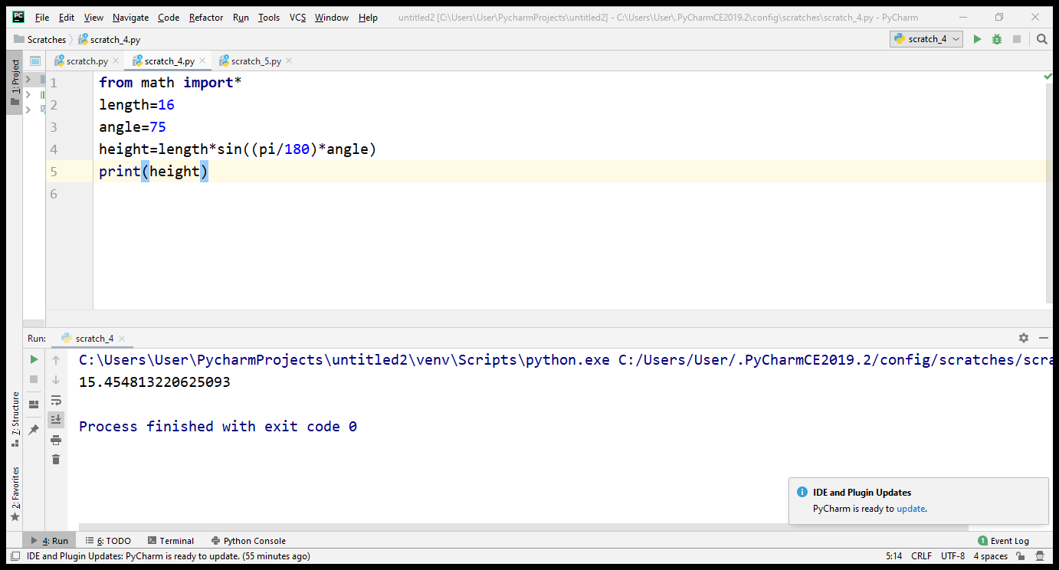

**OUTPUT:**



**(b)20 feet and 0 degrees**

**CODE:**

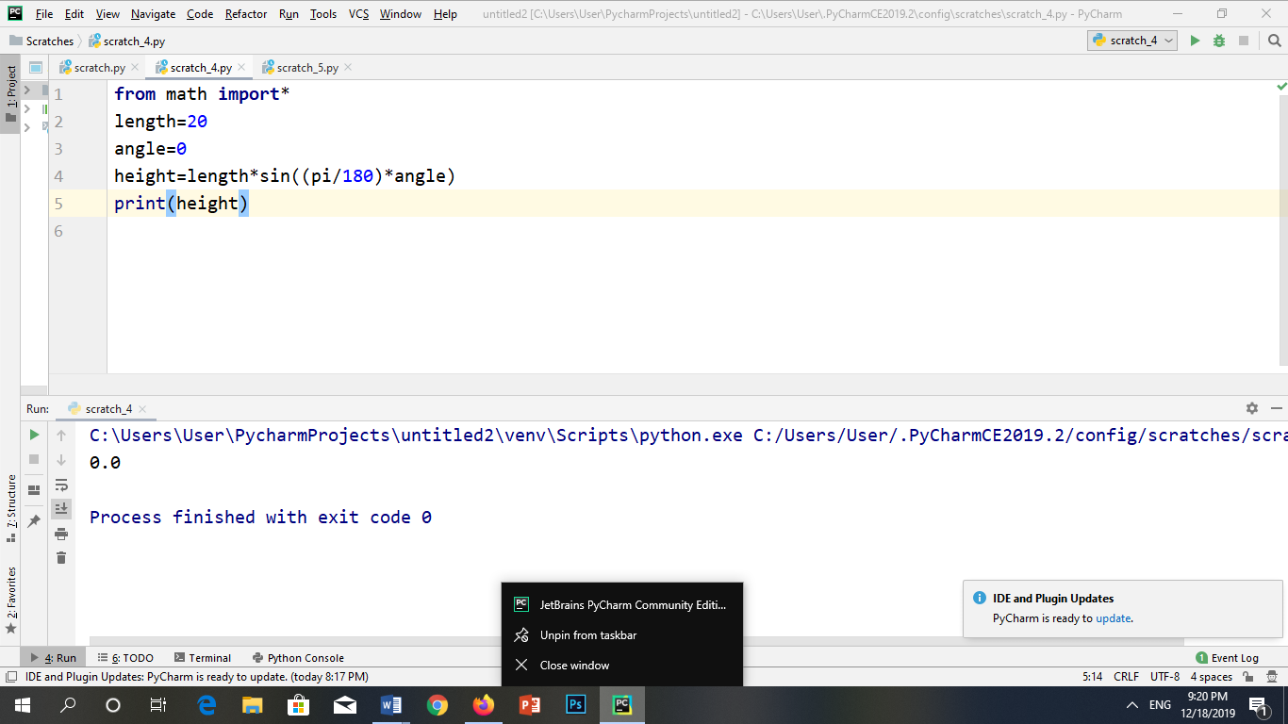

**OUTPUT: **

**(c)24 feet and 45 degrees**

**CODE:**

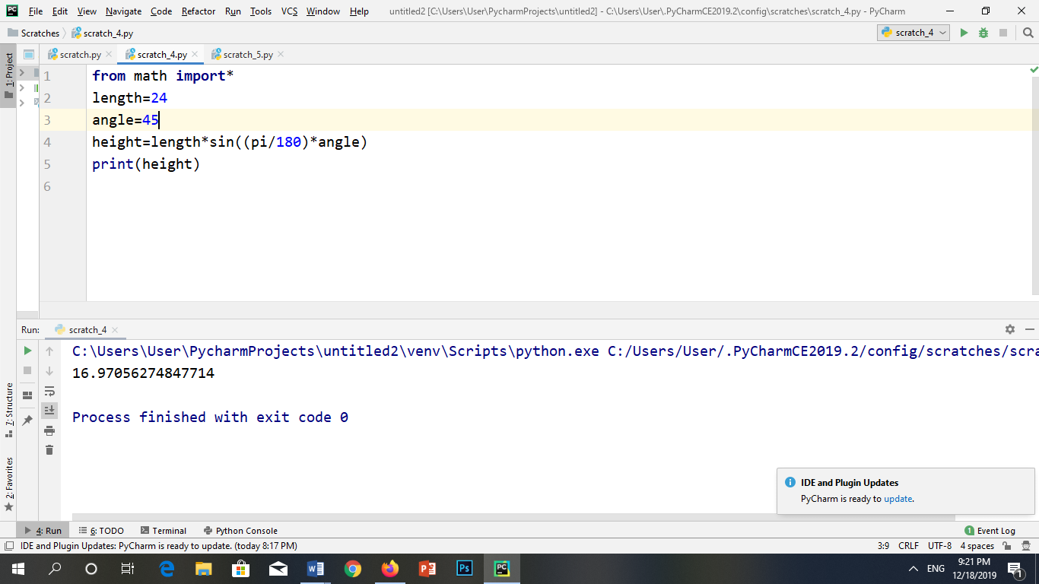

**OUTPUT:**



(d)24 feet and 80 degrees

**CODE:**

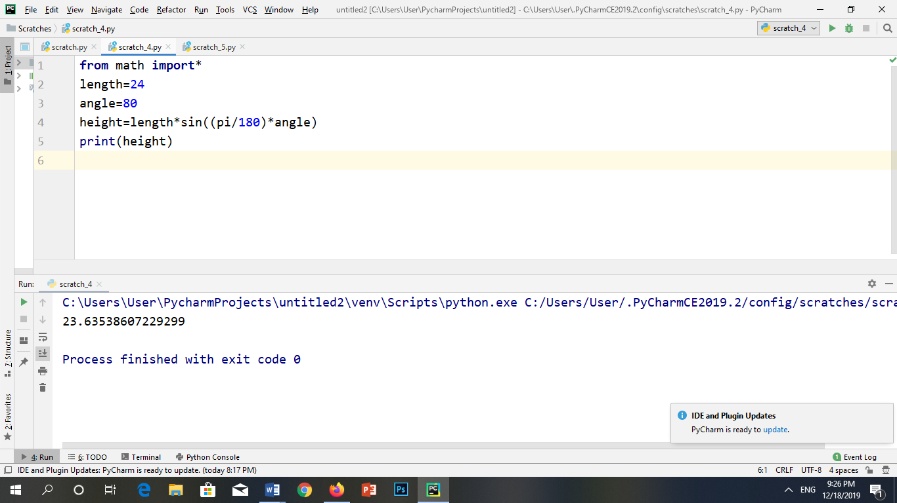

**OUTPUT:**



**Q3.** Write the relevant Python expression or statement, involving a list of numbers list and using list operators and methods for these speciﬁcations:

(a)An expression that evaluates to the index of the middle element of list

(b)An expression that evaluates to the middle element of list

(c)A statement that sorts the list list in descending order

(d)A statement that removes the ﬁrst number of list lst and puts it at the end

**CODE:**

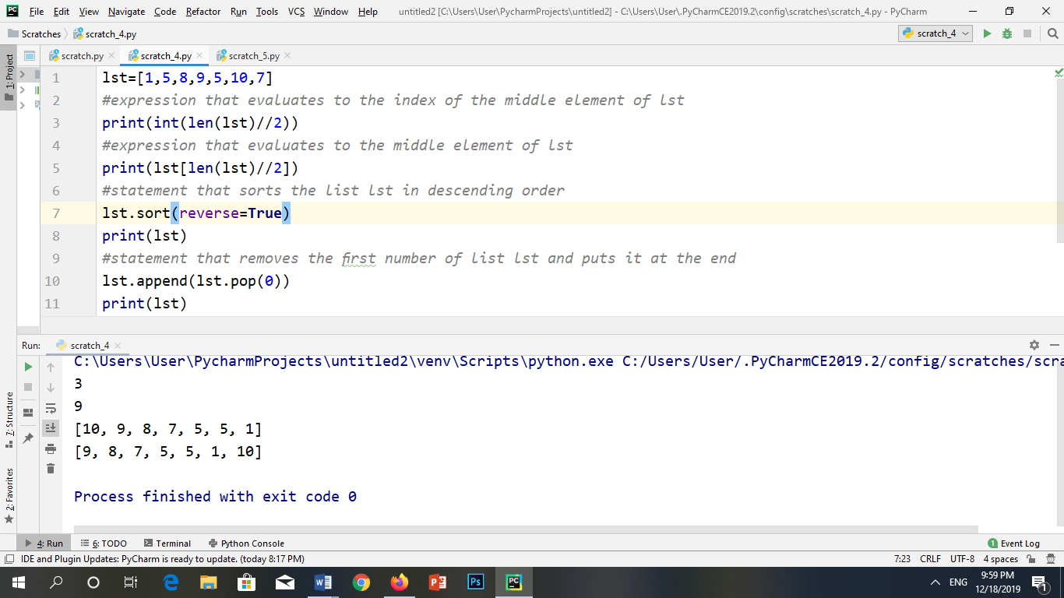

**OUTPUT:**



4. Start by assigning to variables monthsL and monthsT a list and a tuple, respectively, both containing strings 'Jan', 'Feb', 'Mar', and 'May', in that order. Then attempt the following with both containers:

(a)Insert string 'Apr' between 'Mar' and 'May'.

(b)Append string 'Jun'.

(c)Pop the container.

(d)Remove the second item in the container.

(e)Reverse the order of items in the container

**FOR LIST:**

**CODE:**

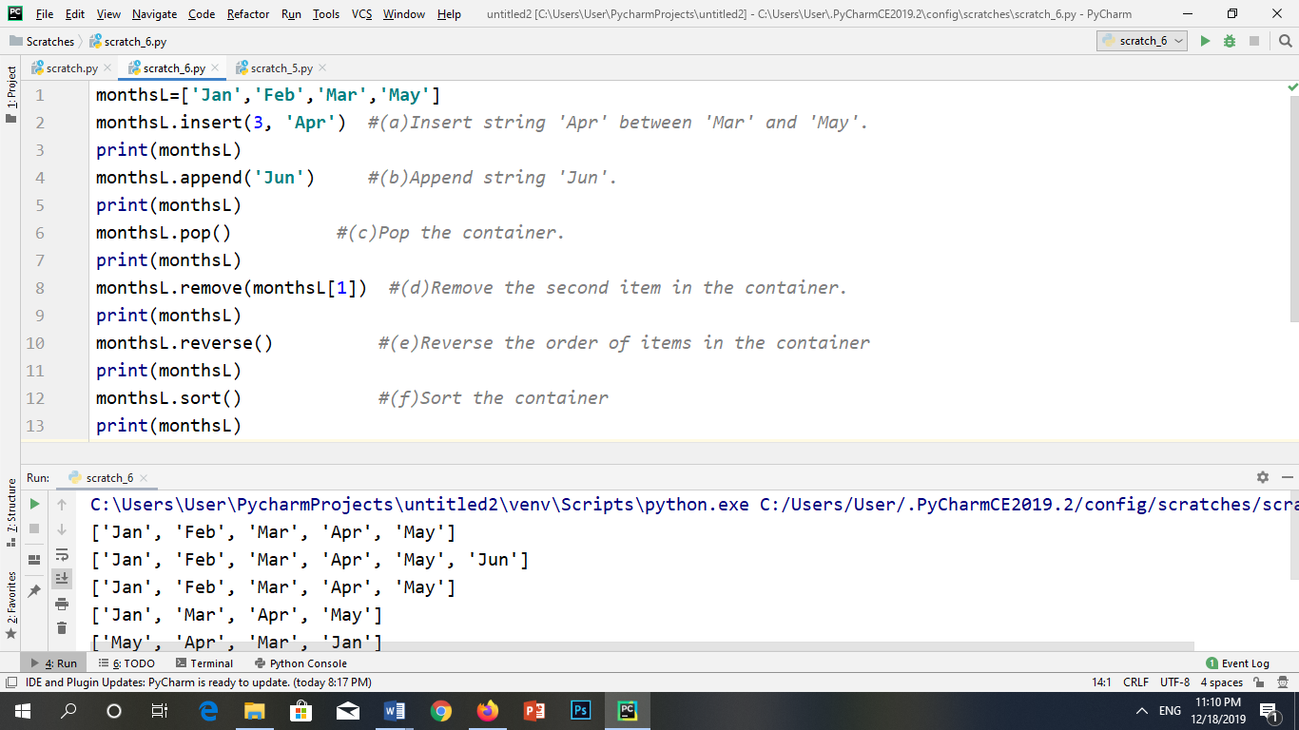

**OUTPUT:**

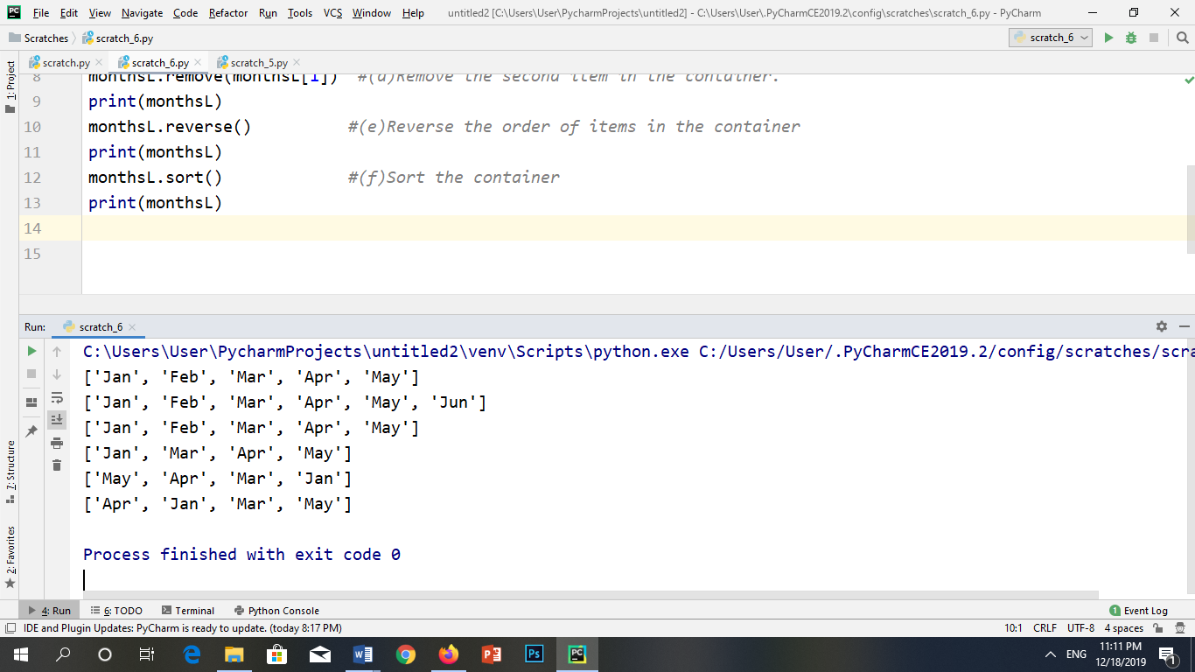

**FOR TUPLE:**

**CODE: (a)**

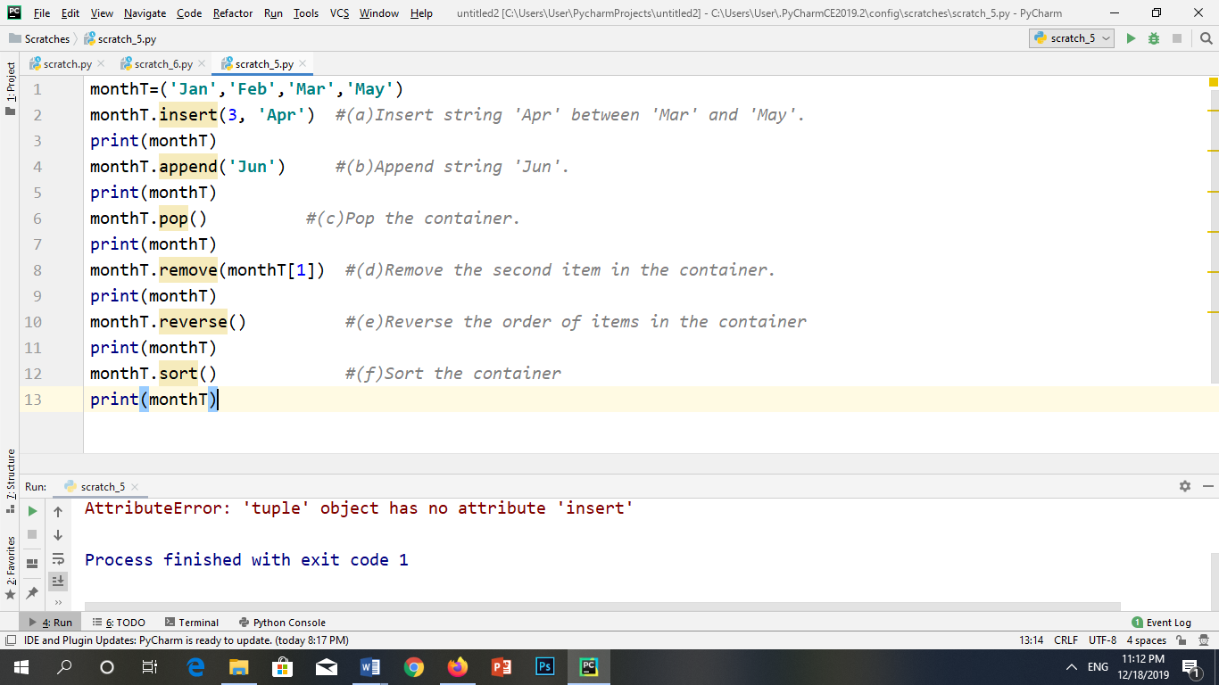

**OUTPUT:**

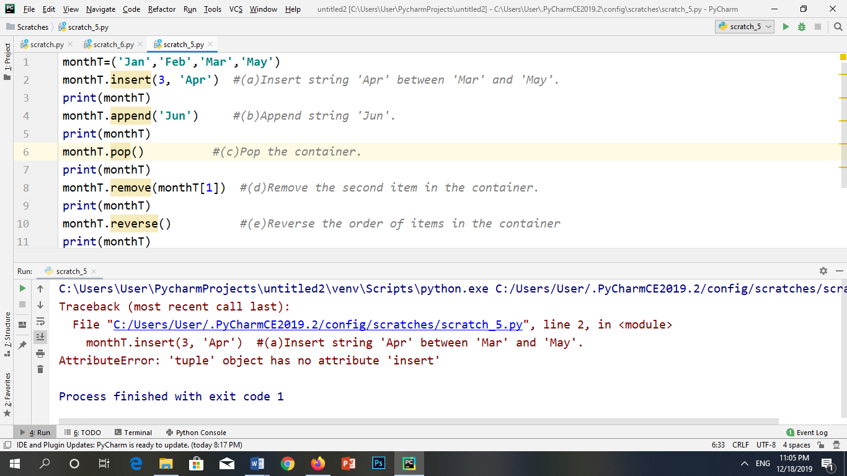

**CODE: (b)**

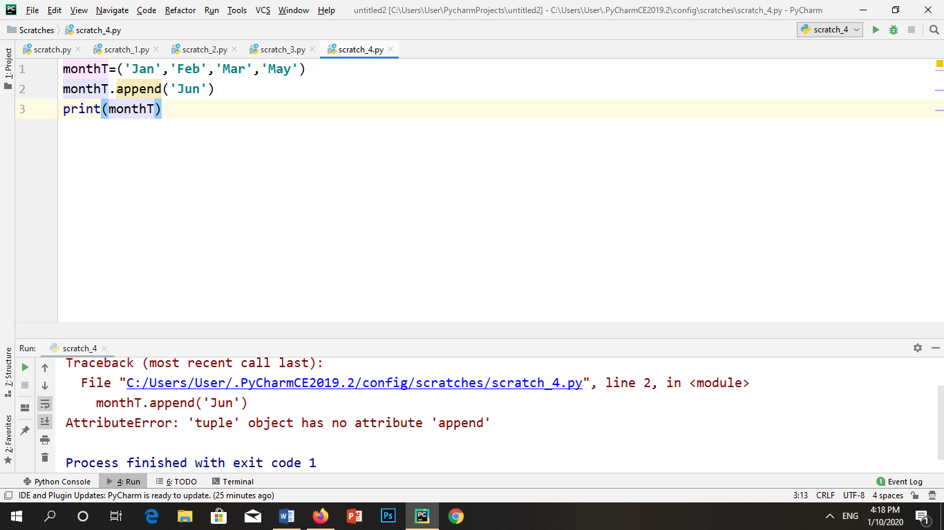

**OUTPUT:**



**CODE: (c)**

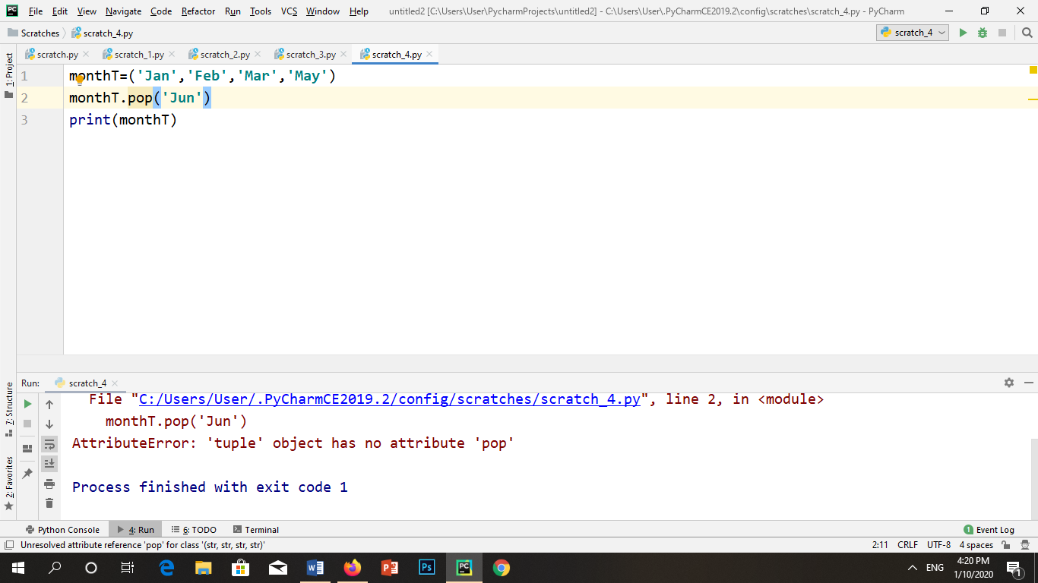

**OUTPUT:**



**CODE: (d)**

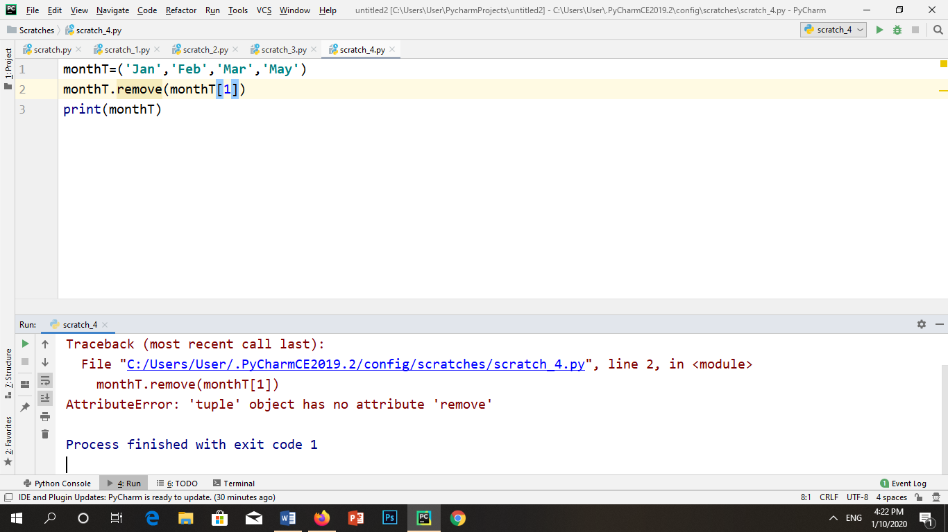

**OUTPUT:**



**CODE: (e)**

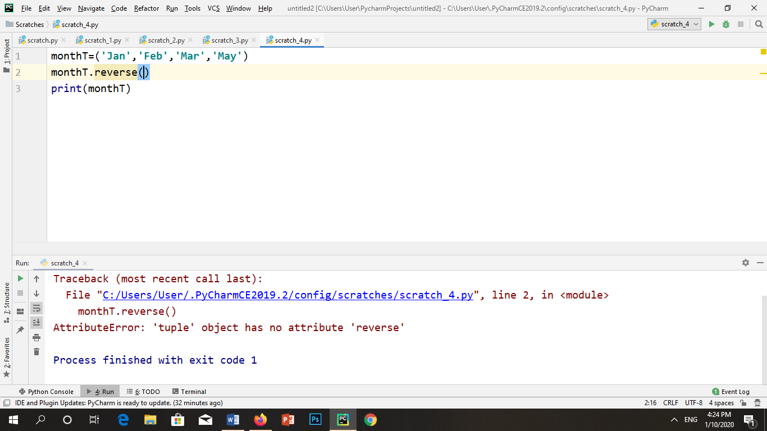

**OUTPUT:**



**CODE: (f)**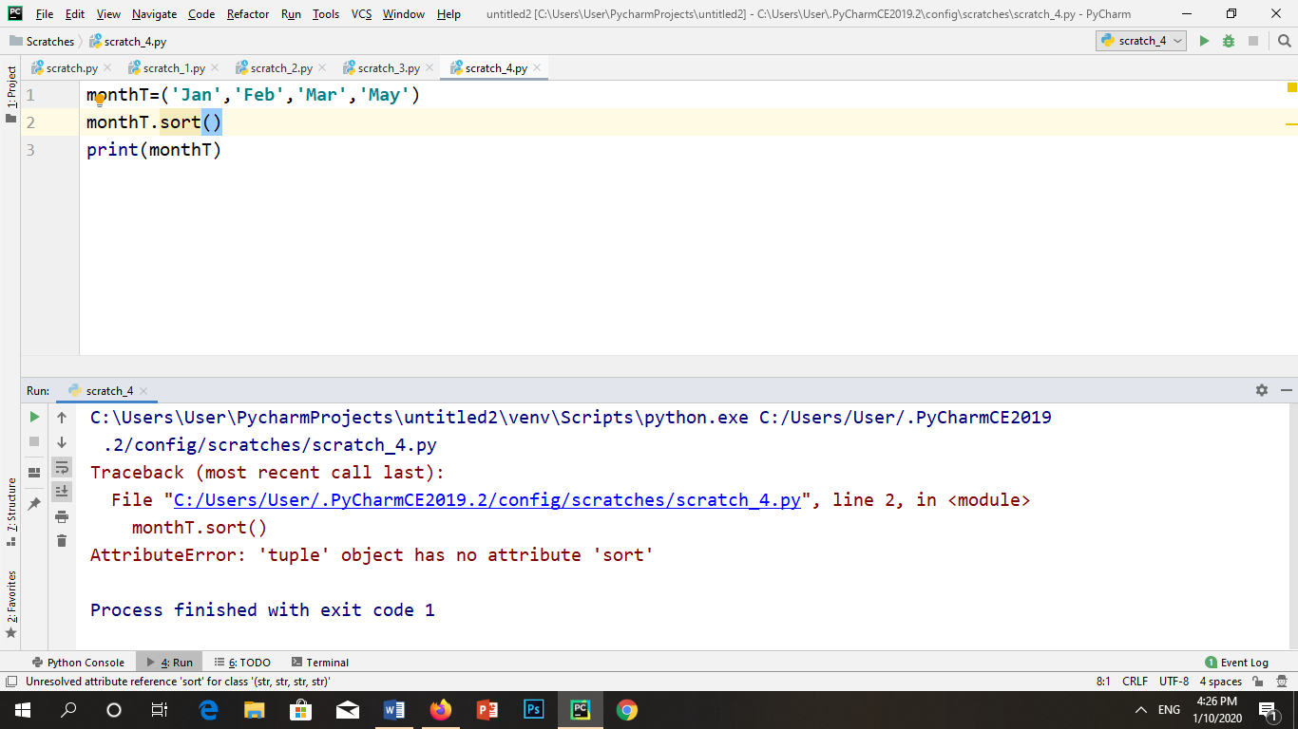

**OUTPUT:**

6. Write the corresponding Python assignment statements: (a)Assign 6 to variable a and 7 to variable b.

(b)Assign to variable c the average of variables a and b.

(c)Assign to variable inventory the list containing strings 'paper', 'staples', and 'pencils'. (d)Assign to variables first, middle and last the strings 'John', 'Fitzgerald', and 'Kennedy'. (e)Assign to variable fullname the concatenation of string variables first, middle, and last. Make sure you incorporate blank spaces appropriately.

